Technical Documentation for

DSTC APP

Written by Paulo Goncalves

Downloading the application

# The DSTC App application is available via google play store and can be downloaded direct using your android device. So far the application is available only for android devices running 4.0 and above.

Link: https://play.google.com/store/apps/details?id=au.edu.holmesglen.econference&hl=en

Getting to know the app

# When you first open the application it shows a tutorial with image and text to help the user on how to use the app.

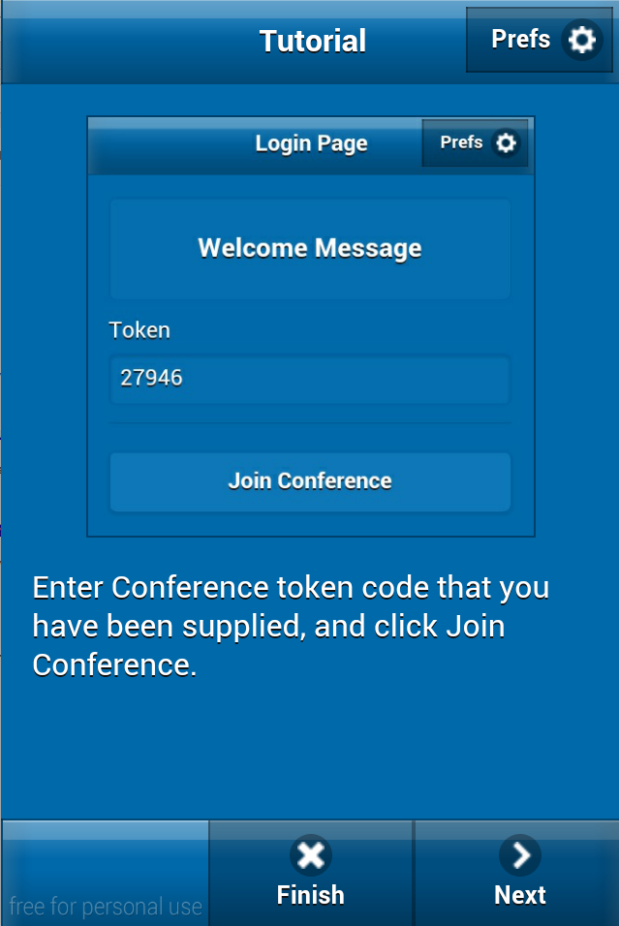

Starting the usage

# The first view will ask the user to enter a token string. This token is a unique identification of the particular presentation that he is about to participate.

* For the token to work the conference has to be set as available.

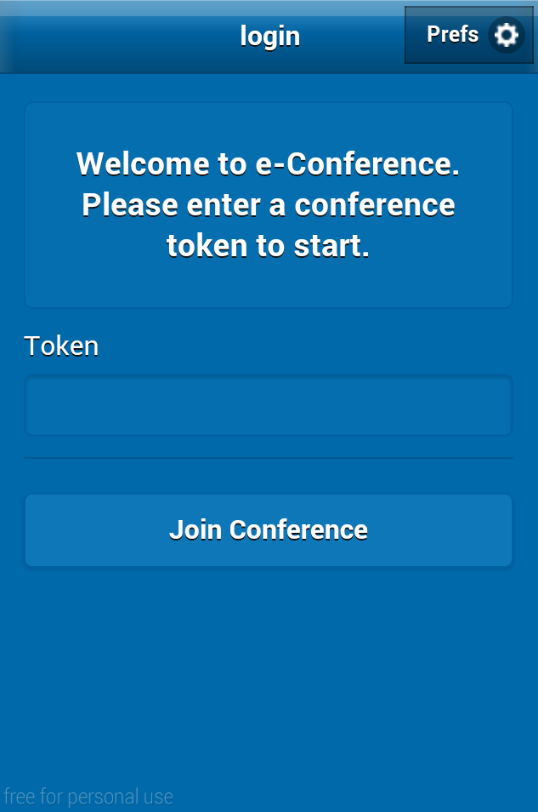

Conference Information

# When the user is granted the access to the conference, he will be presented with the description of the conference.

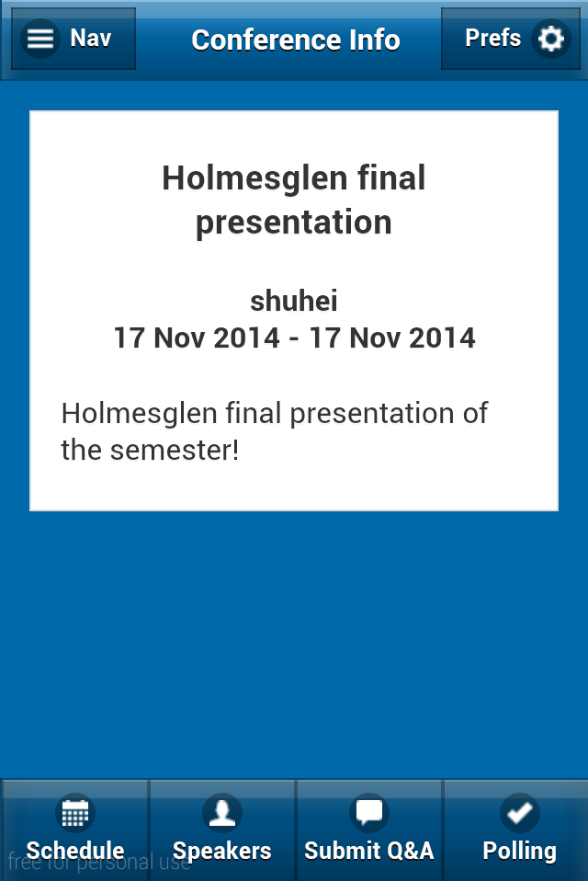

# 

App Navigation

Theapp uses the navigation flow to help user on navigate and access all the functions the app offer.

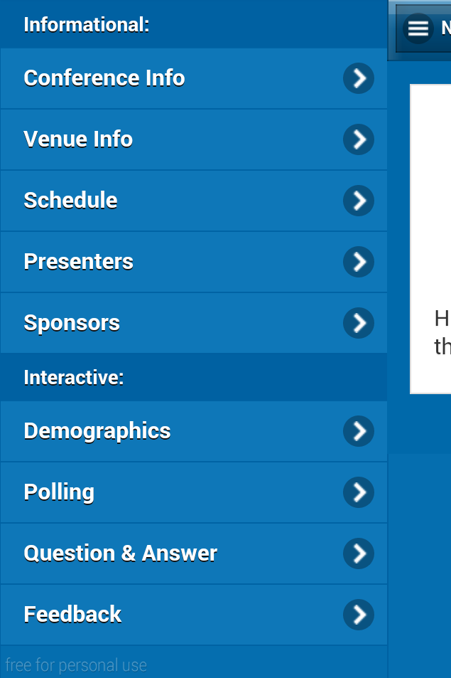

Venue Information

On this view the user will get the detail information of the conference, including floor plan when available.

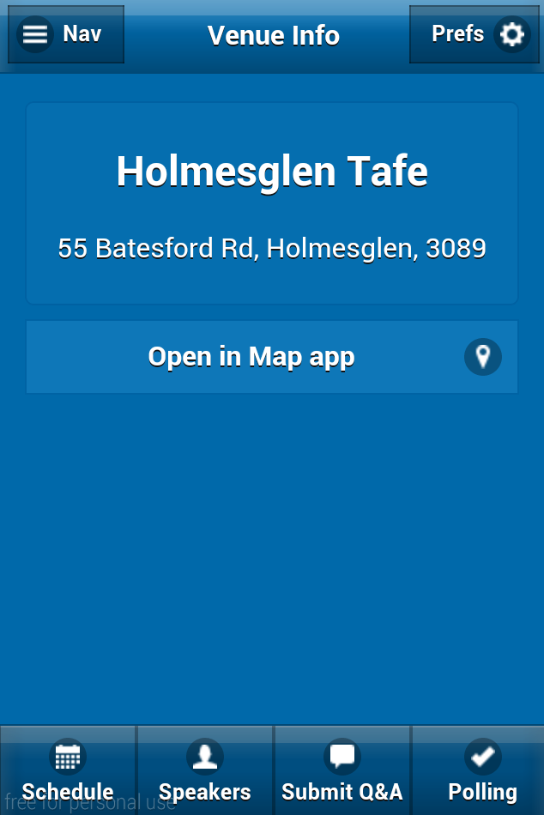

Schedule

This view will display the schedule of the presentation, it will display the sections and session for the specific conference.

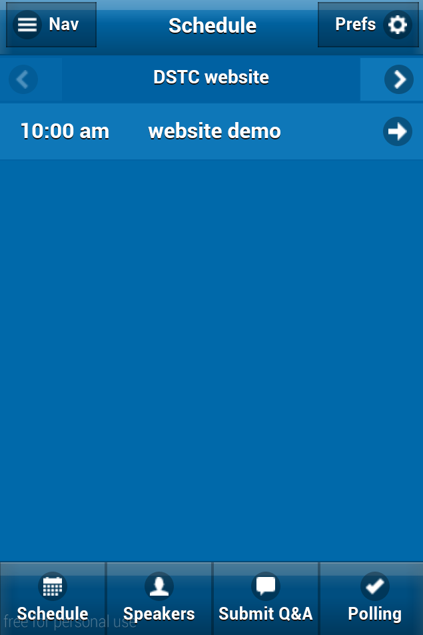

Presenters

This view will display the list of all the presenters for the current conference. The user are able to click on the presenter and see its detail.

|  |  |
| --- | --- |
| Macbook:Users:macbook:Dropbox:Screenshots:Screenshot 2014-11-10 10.27.46.png | Macbook:Users:macbook:Dropbox:Screenshots:Screenshot 2014-11-10 10.31.55.png |

Sponsors

This view will display the sponsor logos and details when available.

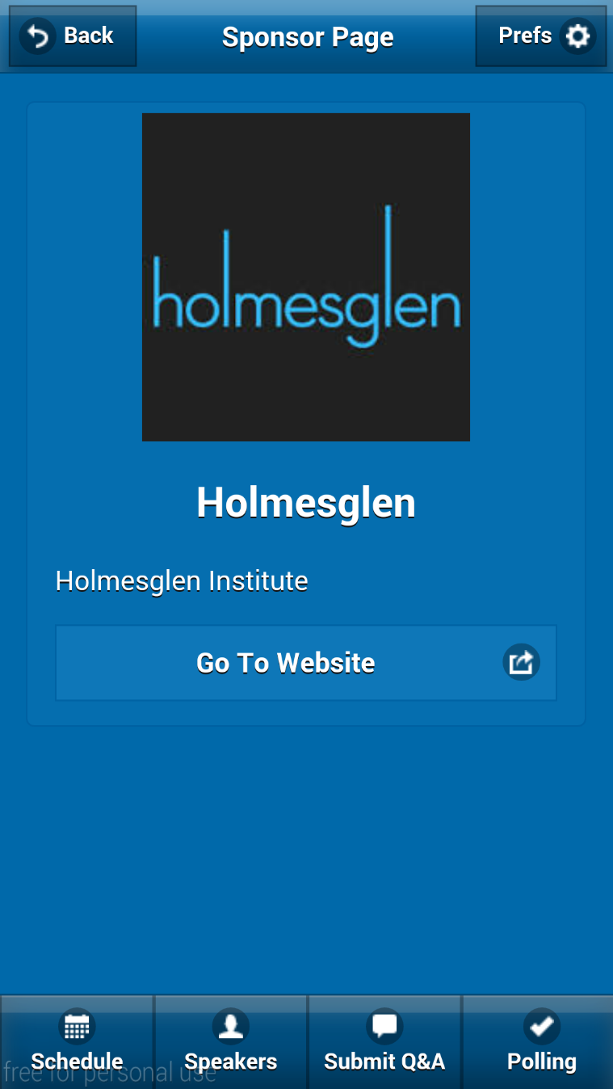

Demographics

This view will display with questions about the user, these questions are going to be added from the dashboard.

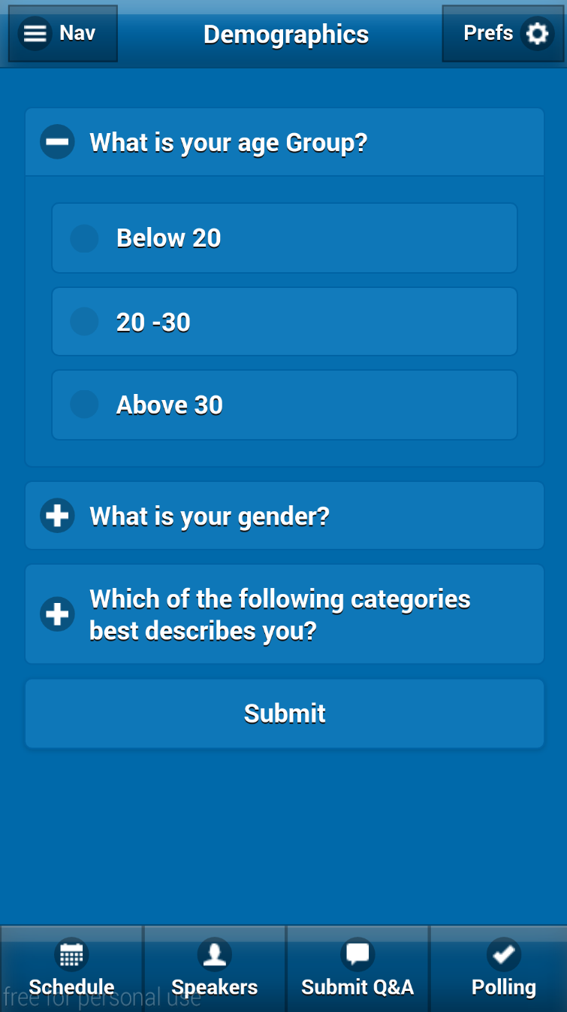

Polling

This view will display questions that the conference organization wants to prompt the user to answer.

* These questions are organized from the dashboard.

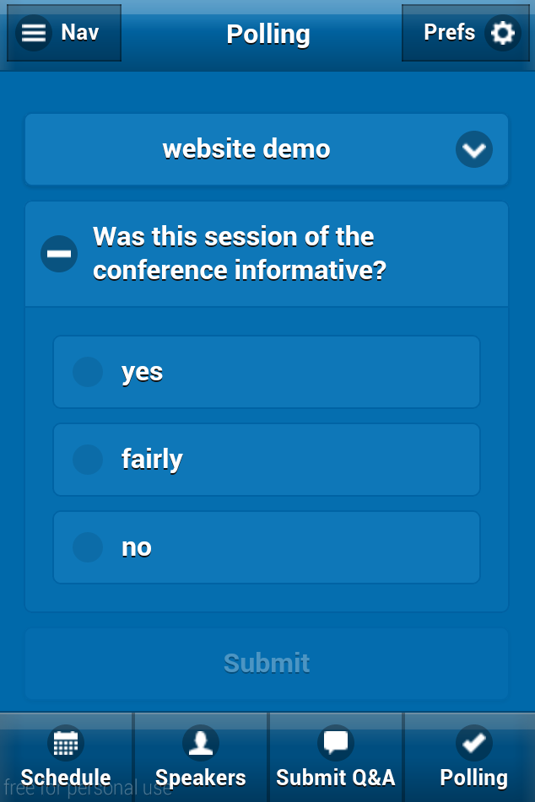

Question and Answer

This view will allow the user to have a direct connection to the presenter, making questions and checking the answers. First the user will be asked to

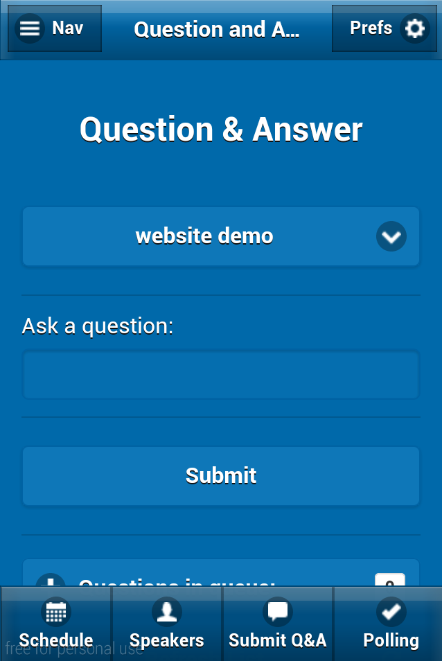

Feedback

This View will allow the user to give a general feedback for specific parts of the conference to be set from the dashboard.

